Natural Disasters!!!!

Find out about a natural disaster. You could chose from:

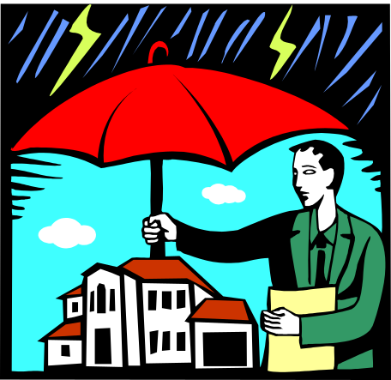
Cyclones (Hurricanes, Typhoons)
Bushfires
Earthquakes
Volcanoes
Floods
Droughts
Tsunamis

Try to find out:

- What things can cause these disasters?

- Why are these events so dangerous and how do they affect property & peoples’ lives?

- What things can people do to prepare for these types of disasters and/or reduce the risks?

- Write a headline newspaper article about a famous example of the type of natural disaster you have chosen. Write it as a reporter who was there when it happened and describe before, during and after the event.

Due Date: ____________________

